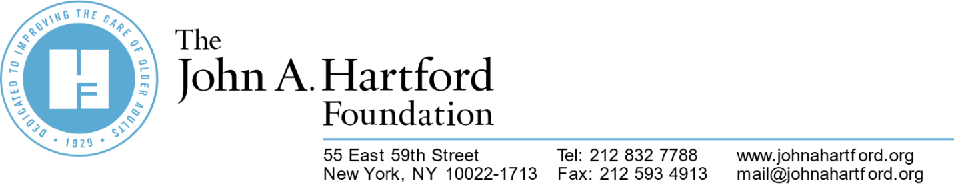

11/7/2024

**Communications Officer**  
The John A. Hartford Foundation  
New York City, NY

If you are a driven professional with a proven track record of success who is passionate about making a difference through the work they do, The John A. Hartford Foundation has a one-of-a-kind opportunity for you to be a part of the nation’s leading philanthropy with a sustained interest in aging and health. To help support our ongoing growth, we are seeking a dynamic team player to join our team as a Communications Officer.

**About Us**

The John A. Hartford Foundation, based in New York City, is a private, nonpartisan philanthropy dedicated to improving the care of older adults. Established in 1929 by John and George Hartford, the founders of the Great Atlantic & Pacific Tea Company (also known as the A&P grocery stores), our Foundation is the nation’s leading philanthropy with a sustained interest in aging and health.

The John A. Hartford Foundation has a distinguished history of investing in aging experts and practice innovations that transform how the care of older adults is delivered. We are committed to equitable care that both drives better health outcomes and lowers costs. In a rapidly evolving healthcare environment, our Foundation supports the spread of evidence-based models that can dramatically accelerate care improvement for older adults, which benefits all of us.**Our programmatic priority areas include creating age-friendly health systems, supporting family caregivers, and improving serious illness and end-of-life care.**

**What Makes this Job so Unique?**  
As a Communications Officer at The John A. Hartford Foundation, you will be responsible for editorial content management and media relations for the Foundation. Working closely with the Vice President, Communication, you will assist in the development of the organization’s overall communications strategy, write and edit content for publications and presentations, respond to media inquiries and manage media partnerships and coordinated communications campaigns with grantees.

The Communications Officer is a key member of the communications team, reporting to the Vice President, Communications and working closely with the Sr. Communications Associate, Communications Assistant, interns and outside consultants.

**Essential Duties and Responsibilities:**

* Participates in the development, implementation and evaluation of the Foundation’s communications strategy and tactics, in partnership with the Vice President of Communication and the communications team.
* Drafts editorial content for digital communications (website, social media, email) and external publication, oversees content development by other team members, and edits and proofs content developed internally and externally.
* Manages day-to-day relationships with select communications consultants and vendors.
* Cultivates reporter contacts, manages media relations and drafts press releases with consultation and support from consultants.
* Manages sponsored media partnerships and campaigns by serving as the main point of contact and first reviewer of all materials.
* Drafts and edits remarks and presentations delivered by Foundation staff, in collaboration with the Communications Assistant.
* Provides strategic communications support to grantees by reviewing and providing feedback on materials; plans the coordinated promotion of events, reports, and other grantee products.

**Desired Qualifications, Education, and Experience:**

* Personally motivated to support the Foundation’s mission and goals.
* Substantial experience in the communications field (5-7 years).
* Relevant experience or knowledge of aging, health care, philanthropy, and non-profit sectors.
* Excellent written and oral communication skills and ability to work quickly and on deadline.
* Impeccable editing and proofreading skills.
* Experience in media pitching and cultivating and maintaining relationships with journalists.
* Strong project and editorial calendar management experience.
* Excellent analytic abilities and critical thinking skills.
* Outstanding interpersonal skills: articulate, collegial, energetic, and able to develop productive relationships with colleagues, Foundation partners, and consultants.
* Welcomes the opportunity to work with people with diverse experiences and perspectives.
* Highly organized, creative, and flexible, with strong project-, people-, and time management skills; demonstrated ability to think independently and juggle multiple priorities.
* Good judgment and maturity; ability to make decisions, problem-solve, justify recommendations, and be responsive and clear.
* Demonstrated efficiency, effectiveness, accuracy, and quick turnaround.
* Advanced proficiency with Microsoft Office suite; experience with email (Mailchimp) and project management (Trello) platforms preferred; interest in AI a plus.
* Ability to work in a highly collaborative and team environment, as well as work autonomously on specific projects.
* Bilingual reading and writing skills a plus.
* Master’s degree or higher preferred.

**Salary and Benefits:**

The John A. Hartford Foundation offers a salary range of $120,000 to $140,000, commensurate with experience. At The John A. Hartford Foundation, employees love what they do and love where they work. We offer great perks like:

* Team- oriented environment
* Competitive salary
* Comprehensive Medical and Dental Plans
* Disability and Life Insurance
* 401(k) with Company Match
* Generous Vacation Plan and Holiday Schedule

**How Do I Get Started?**

To apply, please submit the following to [jobs@johnahartford.org](mailto:jobs@johnahartford.org):

* An updated resume
* A brief cover letter outlining your experience and interest in working for The John A. Hartford Foundation

Please note: If you are offered employment, it will be contingent upon the successful completion of any and all background verifications. Your submission will receive a brief electronic acknowledgement. Due to the anticipated volume of applications further contact by applicants is not allowed. Please no phone calls.  
  
The John A. Hartford Foundation is an affirmative action and equal opportunity employer. All qualified applicants will receive consideration for employment without regard to race, color, religion, sex, disability, age, sexual orientation, gender identity, national origin, veteran status, or genetic information. The John A. Hartford Foundation is committed to providing access, equal opportunity and reasonable accommodation for individuals with disabilities in employment, its services, programs, and activities. To request reasonable accommodation, please contact the HR Department at 610-295-3102.