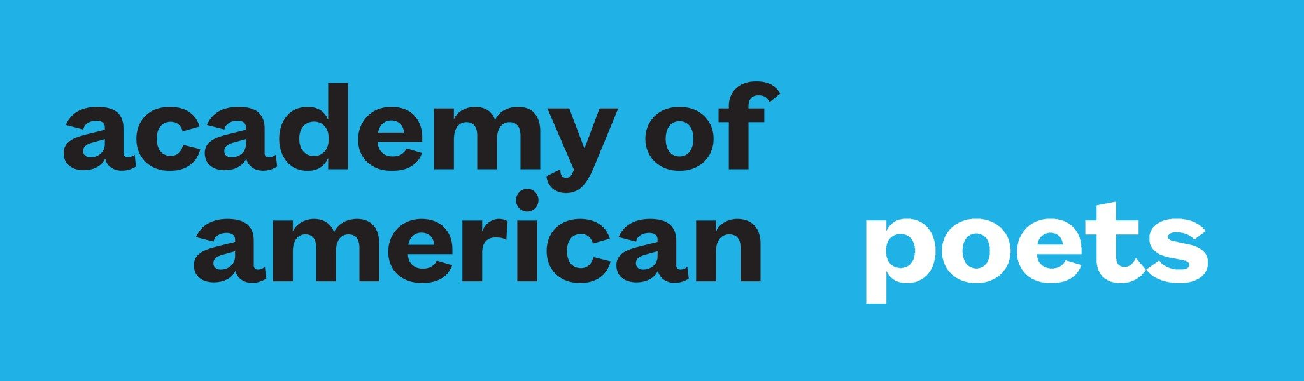

**Search for the President and Executive Director**

**Academy of American Poets**

**New York, New York**

The Academy of American Poets invites applications and nominations for the position of President and Executive Director. Having recently celebrated its 90th anniversary, the Academy’s mission to advocate for and increase the visibility of poets and poetry has never been more vital. This is an exceptional opportunity for an experienced and grounded leader, ideally with a passion for poetry or the arts and culture at large, who can mobilize members, donors, the Board, Chancellors, and staff around a compelling vision for the future as this venerable arts organization looks toward its centennial.

The Academy of American Poets is the nation’s leading champion of poets and poetry with supporters in all fifty states and around the world. The Academy fulfills its mission through a range of programs, including Poets.org, the world’s largest website for poets and poetry; prominent awards and prizes; National Poetry Month; the popular Poem-a-Day series; and *American Poets* magazine. The organization also plays a critical role in bringing poetry into schools through its award-winning resources for K-12 educators. In addition, the Academy plays a leadership role in the national Poetry Coalition, working to promote the value poets bring to our culture.

Reporting to the Board of Directors, the President and Executive Director is the chief executive of the Academy, leading a team of ten full-time employees, as well as consultants and interns, with an annual operating budget of $5 million. Working collaboratively to develop a compelling vision for the future of an esteemed arts organization, the next President and Executive Director will foster a healthy organizational culture supported by a collaborative, high-functioning team; serve as a compelling advocate for the work of poets; expand visibility of poetry; strengthen philanthropy and grow membership. This is a permanent, full-time position in New York, New York, with a starting salary range of $170,000-$200,000, not including benefits, commensurate with experience.

Screening of complete applications will begin immediately and continue until the close of the search process. Electronic submission of materials is strongly encouraged. Inquiries, nominations, referrals, and CVs with cover letters should be sent via the Isaacson, Miller website for the search:

<https://www.imsearch.com/open-searches/academy-american-poets/president-and-executive-director>